**Name :** Ahmed Abd Alrady Fawzy

**B.N:** 81

**Date :** 27/5/2020

**Topic:** Computer Architecture

**Github link :**

**Github page :** **/**

**Application brief :**

An architecture for information processing devices which allows the construction of low cost, high performance systems for specialized computing applications involving sensor data processing. The reconfigurable processor architecture of the invention uses a programmable logic structure called an Adaptive Logic Processor (ALP). This structure is similar to an extendible field programmable gate array (FPGA) and is optimized for the implementation of program specific pipeline functions, where the function may be changed any number of times during the progress of a computation. A Reconfigurable Pipeline Instruction Control (RPIC) unit is used for loading the pipeline functions into the ALP during the configuration process and coordinating the operations of the ALP with other information processing structures, such as memory, I/O devices, and arithmetic processing units. Multiple components having the reconfigurable architecture of the present invention may be combined to produce high performance parallel processing systems based on the Single Instruction Multiple Data (SIMD) architecture concept.

The Warp machine is a systolic array computer of linearly connected cells, each of which is a programmable processor capable of performing 10 million floating-point operations per second (10 MFLOPS). A typical Warp array includes ten cells, thus having a peak computation rate of 100 MFLOPS. The Warp array can be extended to include more cells to accommodate applications capable of using the increased computational bandwidth. Warp is integrated as an attached processor into a Unix host system. Programs for Warp are written in a high-level language supported by an optimizing compiler.

The first ten-cell prototype was completed in February 1986; delivery of production machines started in April 1987. Extensive experimentation with both the prototype and production machines has demonstrated that the Warp architecture is effective in the application domain of robot navigation as well as in other fields such as signal processing, scientific computation, and computer vision research. For these applications, Warp is typically several hundred times faster than a VAX 11/780 class computer. This paper describes the architecture, implementation, and performance of the Warp machine. Each major architectural decision is discussed and evaluated with system, software, and application considerations. The programming model and tools developed for the machine are also described. The paper concludes with performance data for a large number of applications.

**Screenshots :**

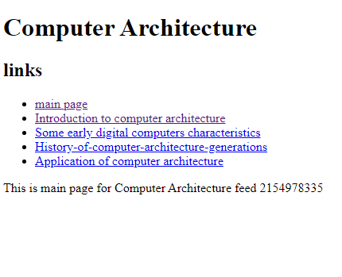

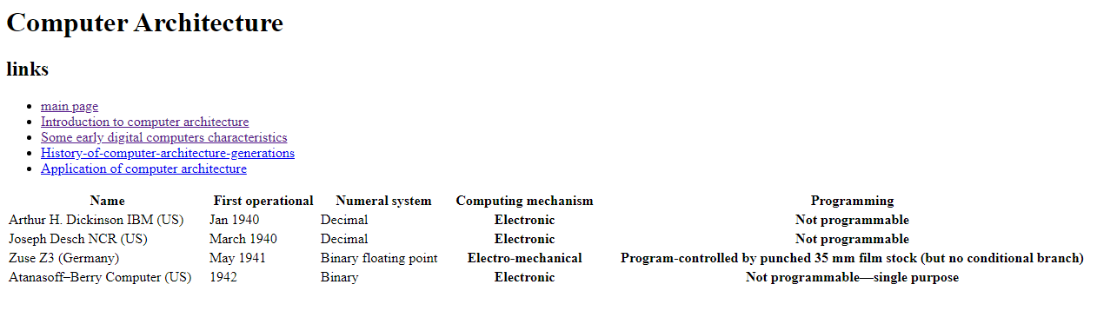

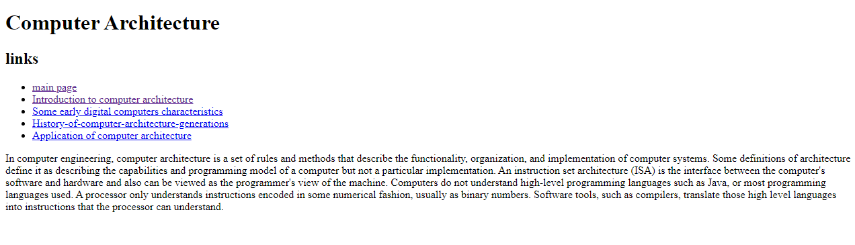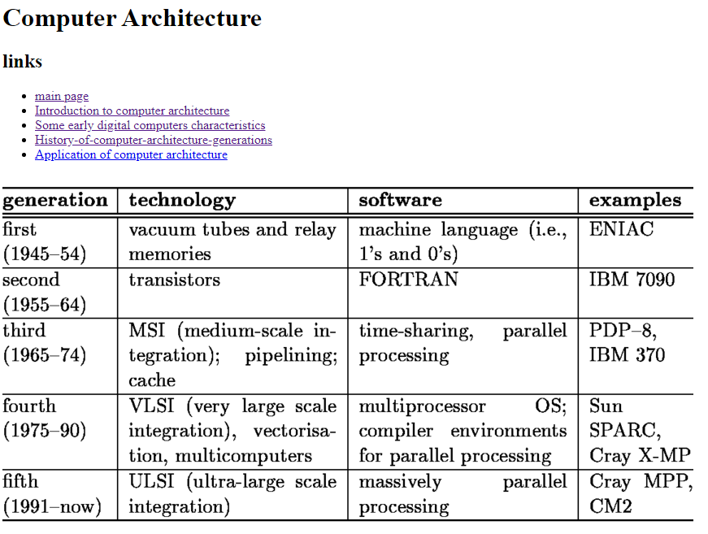

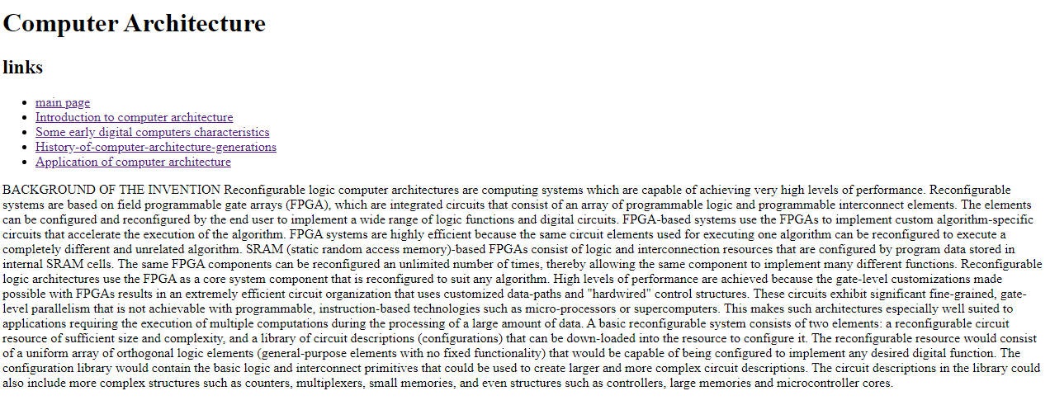

**Source code**